## DELEGATES

Delegates are users who have been granted permissions to manage another user’s Direct inbox, including reading messages, replying/forwarding, and composing new messages. Each user is able to add and remove delegates at any time using the **Settings** tab on the *Messages* screen.

### Adding Delegates

To find and add delegates, click on **Add new account** in the *Delegates* section. When the *New Delegate Email Address* window appears, begin typing the first or last name of the user to perform a search. The system will autocomplete your entry if matches are is found. Select the correct address and then click the **Save** button.

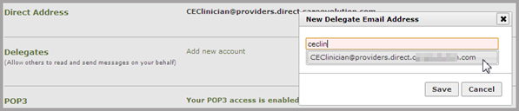

### Acting as a Delegate

If another user has added you as a delegate, you can access his or her Direct account by clicking on **Change** the upper right of your Direct inbox screen.

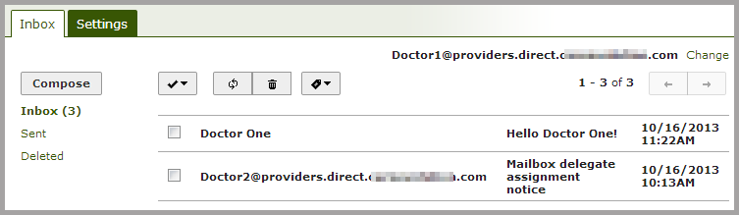

The *Choose Mailbox…* window will appear. Click on the dropdown list to choose a user’s Direct account.

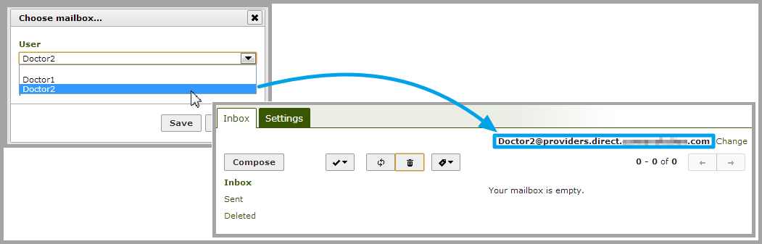

As a delegate, you will be able to read, write, reply to, and forward Direct messages within the delegated inbox. Users should keep in mind their organization’s privacy and security policies before setting up any delegates.

Note: only the original inbox owner can assign and delete delegates to his or her inbox.

Messages sent by a delegate will include a notification that they were sent on behalf of another user.

